ALLAMA IQBAL OPEN UNIVERSITY, ISLAMABAD
(Department of Computer Science)

WARNING
- PLAGIARISM OR HIRING OF GHOST WRITER(S) FOR SOLVING THE ASSIGNMENT(S) WILL DEBAR THE STUDENT FROM AWARD OF DEGREE/CERTIFICATE, IF FOUND AT ANY STAGE.
- SUBMITTING ASSIGNMENTS BORROWED OR STOLEN FROM OTHER(S) AS ONE’S OWN WILL BE PENALIZED AS DEFINED IN “AIOU PLAGIARISM POLICY”.

Course: Theory of Automata (3452) Semester: Spring, 2011
Level: BS (CS) Total Marks: 100

ASSIGNMENT No. 1

Note: All questions carry equal marks.

Q.1 What is a set? Also explain the different types of set operations with examples.

Q.2 (a) Define finite language? List the different functions that can be applied to a finite language?
(b) Differentiate between Kleen Closure and a positive closure with the help of examples?

Q.3 (a) What is recursive definition? Write down the recursive definition for the set of positive even integers.
(b) Give recursive definition of the following languages defined over alphabet Σ = {a, b},
i. All strings starting with a or b
ii. All strings ending with aa.
iii. All strings NOT ending with a.
iv. All strings NOT ending with bb.
v. All strings having aa at any place.
vi. All strings NOT having aa at any place.

Q.4 Give Regular Expression for each of the following language defined over alphabet Σ = {a, b}
i. All strings STARTING with a or b
ii. All strings NOT having ab
iii. All strings NOT having bb
iv. All strings HAVING aa
v. All strings HAVING bba
vi. All strings NOT having two consecutive a's
vii. All strings NOT having even no of a's and b's

Q.5 Give Finite Automata for each of the following languages defined over alphabet Σ = {a, b)
i. All strings STARTING with a or b
ii. All strings NOT having ab
iii. All strings NOT having bb
iv. All strings HAVING aa
v. All strings HAVING bba
vi. All strings NOT having two consecutive a's
vii. All strings NOT having even no of a's and b's

ASSIGNMENT No. 2
Total Marks: 100

Note: All questions carry equal marks.

Q.I (a) Differentiate between Context Free Grammar and Regular Grammar. What are the conditions when a Context Free Grammar is also called a Regular Grammar?
(b) Consider the following Context Free Grammar (CFG)
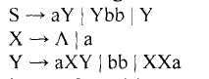
a) Is the CFG ambiguous, if yes then justify your answer.
b) Draw a Total Language Tree (TLT) for the given CFG.
c) Convert the CFG into CNF.
d) Build the PDA corresponding to the CFG (in CNF) of part (c).

Q.2 (a) Do the comparison between a Moore machine and Mealy machine
(b) Given the grammar G:
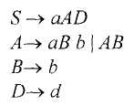
Reduce the grammar G to Chomsky Normal Form.

Q.3 (a) Explain the Normal Forms of CFGs?
(b) Prove the statement that "any CFG has an equivalent PDA and vice versa".

Q.4 (a) Explain the Finite Automata and Pushdown Automata.
(b) State the pumping lemma for CFG. Also give the proof for pumping lemma.
(c) Convert the following Finite Automaton into Pushdown Automaton:
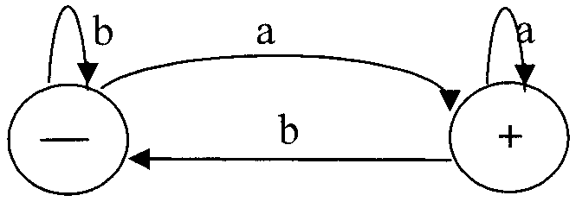

Q.5 (a) Generate the Context-Free Grammars that give the following languages.
(a) {w | w contains at least three 1 s}
(b) {w | w starts and ends with the same symbol}
(c) {w | the length of w is odd}
(d) {w | w = wr, that is, w is a palindrome}
(b) Convert the following NFA to DFA.
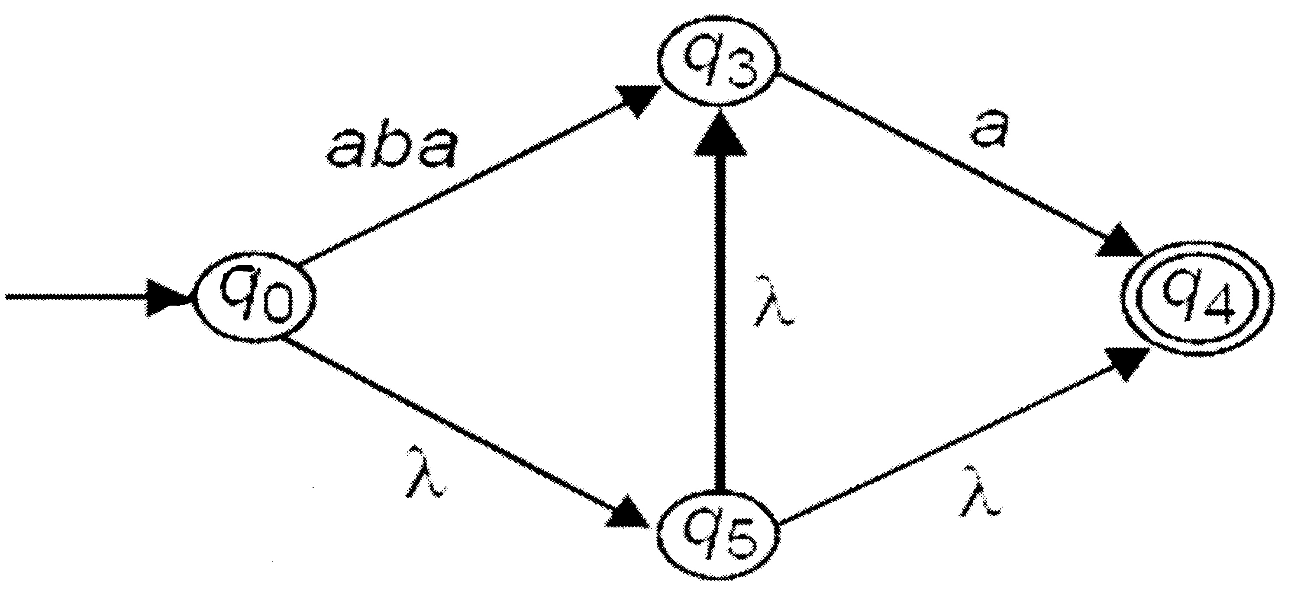
(c) Consider the NFA shown below.
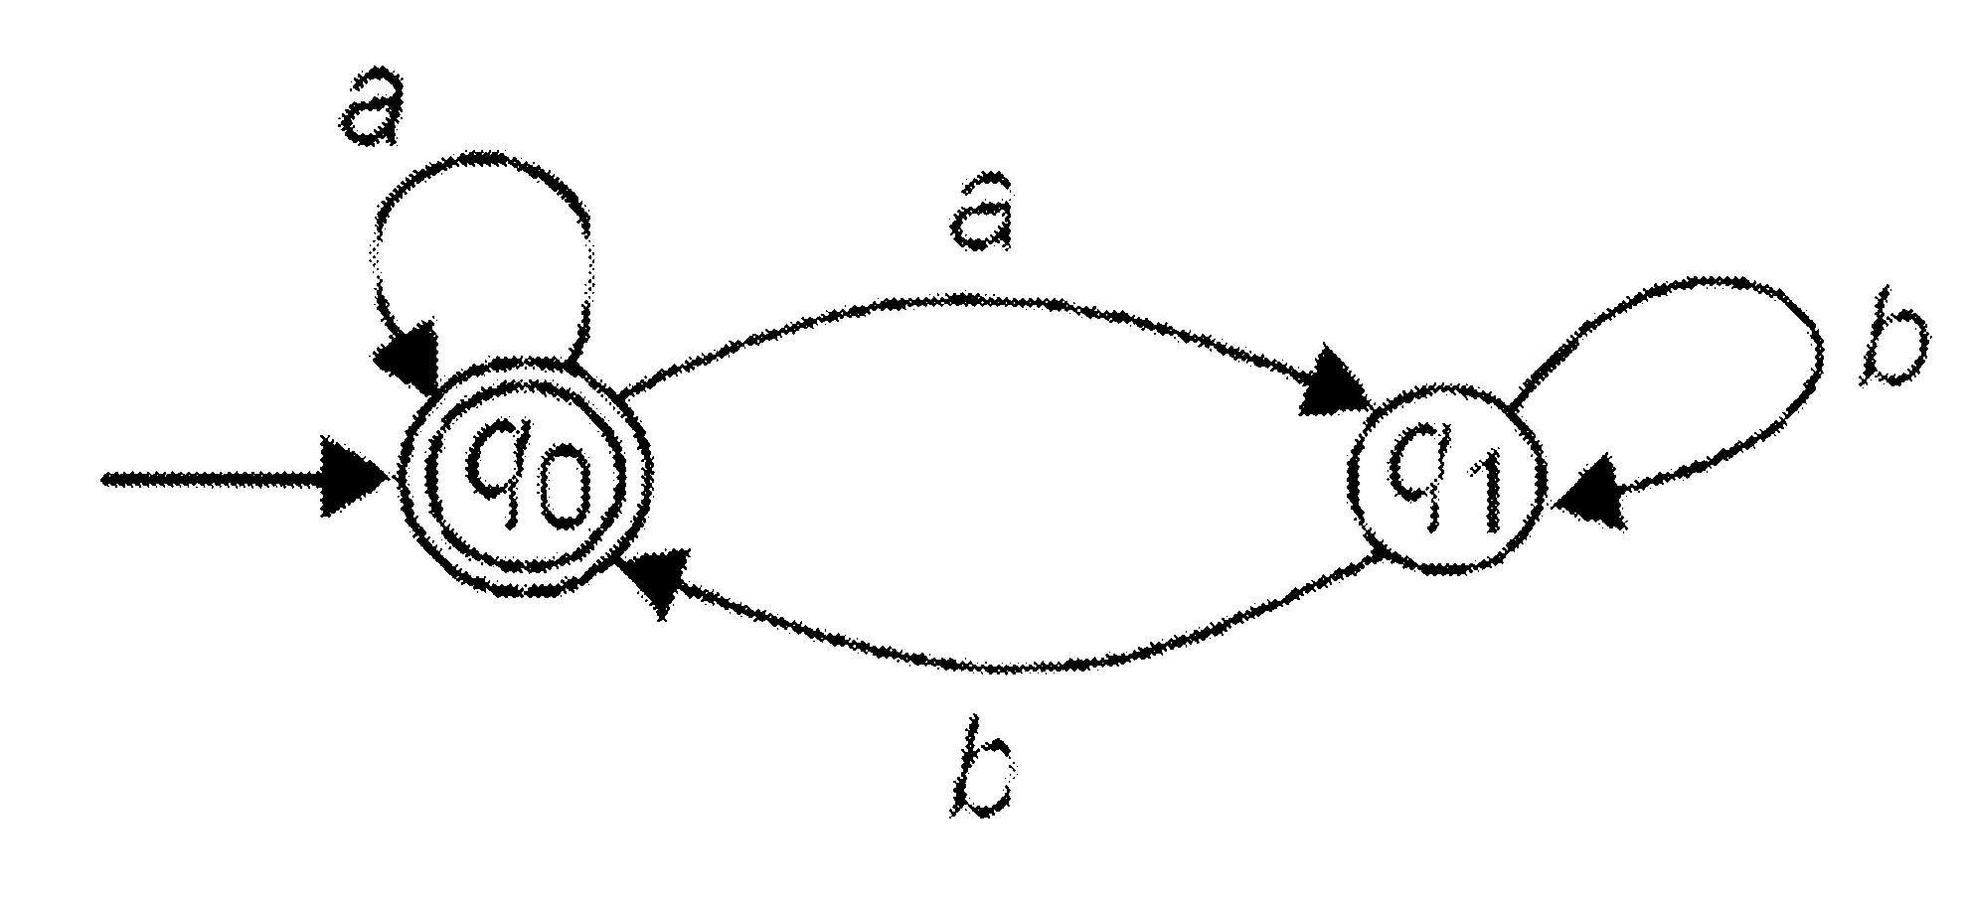
(a) Construction an equivalent DFA.
(b) Give an equivalent regular expression.

3452 Theory of Automata Credit Hours: 3 (3+0)
Recommended Book:
Introduction to Computer Theory by Denial I. A. Cohen

Course Outlines:
Unit No. 1 Mathematical Preliminaries
Set theory, relations and Functions, Recursive Definitions, Directed Graphs and Mathematics

Unit No. 2 Languages
Strings and Languages, Finite Specification of Languages, Regular Sets and Expression

Unit No. 3 Context-Free Grammars
Context-free Grammars and Languages, regular Grammar and Arithmetic Expression

Unit No. 4 Parsing
Leftmost Deviations and Ambiguity, Regular Grammars, Bottom-up Parsing shift Reducer Parser.

Unit No. 5 Normal Forms
Elimination of Lambda Chain Rules, Chomaky Normal Form, Greibach Normal Form.

Unit No. 6 Finite Automata
Finite State Machine, Deterministic Finite Automata, Nondeterministic Finite Automata, Lambda Transitions, Expression Graphs

Unit No.7 Regular Languages
Regular Grammar and Finite Automate, Non-regular Language, Pumping Lemma for Regular Language, Closure Properties of Regular Languages

Unit No. 8 Pushdown Automata and Context-free Languages
Pushdown Automata, Push Down Automata and Context-free language, Pumping Lemma for Context-Free Languages.

Unit No. 9 Turing Machine
Standard Turing machine, Multiple Machines, Nondeterministic, Turing Machines

